Agricultural Crop Production Analysis
Basic Data Analytics Portfolio Project

Sector | Agriculture, Food Security, Public Policy
Tools | Python, Pandas, NumPy, Matplotlib, Excel, SQL
Dataset | Synthetic FAOSTAT-style demo dataset
Latest demo year | 2024
Main output | Excel workbook, Word report, PDF report, scripts, notebooks, ZIP package

1. Project Overview
This project analyzes crop production, harvested area, and yield indicators to demonstrate a complete data analytics workflow for agricultural decision-making. The purpose is to show how a data analyst can convert raw agricultural production data into business questions, clean datasets, KPIs, visual outputs, and policy-oriented recommendations.

2. Data Note
The included dataset is synthetic and is designed only for portfolio demonstration, training, and code review. It follows a FAOSTAT-style structure with crop, year, production, harvested area, and yield fields. For official decision-making, the synthetic data must be replaced with verified official data from FAOSTAT, the Azerbaijan State Statistical Committee, World Bank, or other authoritative sources.

3. Business Problem
Agricultural production can increase due to harvested area expansion, yield improvement, or both. Looking only at production volume may create misleading conclusions. This project separates production, area, and yield to identify whether growth is productivity-driven or area-driven.

4. Business Questions
- Which crops have the highest production volume?
- Which crops show stronger production and yield growth?
- Is production growth driven by harvested area or productivity?
- Which crops show higher volatility and planning risk?
- Which crops should be prioritized for further monitoring and policy support?

5. Success Metrics
Metric | Definition
Total production | Sum of crop production in tonnes
Harvested area | Total harvested area in hectares
Weighted yield | Production-weighted productivity indicator
YoY growth | Annual growth percentage by crop
Production share | Crop contribution to total production
Volatility score | Standard deviation of YoY production growth

6. Dataset Description
The raw dataset is stored in a long FAOSTAT-style format. The processed dataset is reshaped into a wide analytical table where each crop-year observation contains harvested area, yield, production, growth metrics, production share, and volatility score.
column_name | data_type | description
country | string | Country name
iso3_code | string | ISO-3 country code
year | integer | Observation year
crop | string | Crop/product name
area_harvested_ha | float | Harvested area in hectares
yield_kg_per_ha | float | Crop yield in kilograms per hectare
production_tonnes | float | Production volume in metric tonnes
production_yoy_growth_pct | float | Year-over-year production growth percentage by crop
yield_yoy_growth_pct | float | Year-over-year yield growth percentage by crop
area_yoy_growth_pct | float | Year-over-year harvested area growth percentage by crop
production_share_pct | float | Crop share in total crop production for the year
yield_tonnes_per_ha | float | Crop yield in tonnes per hectare

7. Data Cleaning and Validation
The cleaning process standardizes column names, reshapes the long dataset into a wide format, validates country-year-crop uniqueness, checks missing values, checks duplicates, and confirms that production, area, and yield values are non-negative.

8. Exploratory Data Analysis
In the latest demo year (2024), total crop production in the synthetic dataset is 8,724,019 tonnes, harvested area is 1,419,928 hectares, and the weighted yield is 6,144 kg/ha.

8.1 Latest-Year Crop Summary
crop | production_tonnes | area_harvested_ha | yield_kg_per_ha | production_share_pct | volatility_score
Wheat | 2,219,608 | 642,463 | 3,455 | 25.44 | 9.81
Vegetables | 1,855,483 | 82,149 | 22,587 | 21.27 | 7.24
Fruits and berries | 1,499,323 | 159,760 | 9,385 | 17.19 | 6.40
Potatoes | 1,099,300 | 56,900 | 19,320 | 12.60 | 7.86
Barley | 1,089,514 | 346,942 | 3,140 | 12.49 | 9.82
Maize | 318,101 | 44,515 | 7,146 | 3.65 | 12.38
Sugar beet | 317,044 | 6,867 | 46,167 | 3.63 | 8.27
Grapes | 197,377 | 19,098 | 10,335 | 2.26 | 11.41
Cotton | 96,930 | 47,616 | 2,036 | 1.11 | 8.17
Sunflower seed | 31,339 | 13,618 | 2,301 | 0.36 | 11.59

8.2 Production Trend
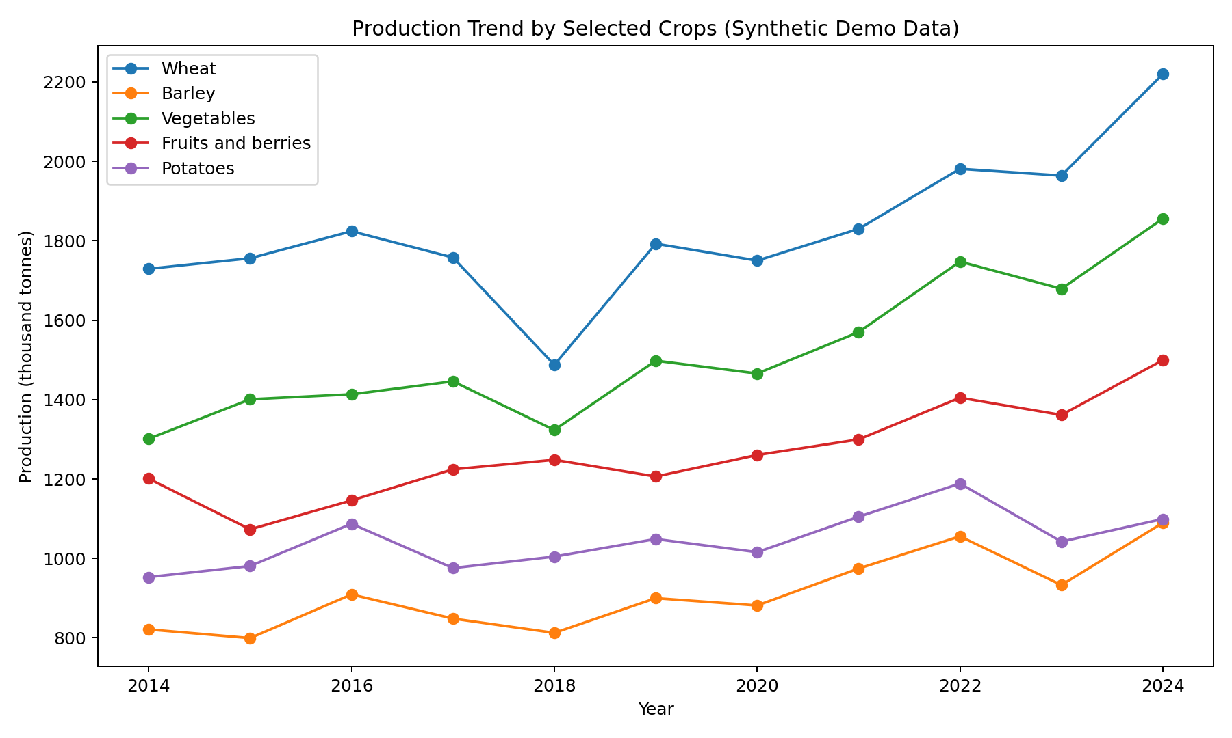

8.3 Top Crops by Production
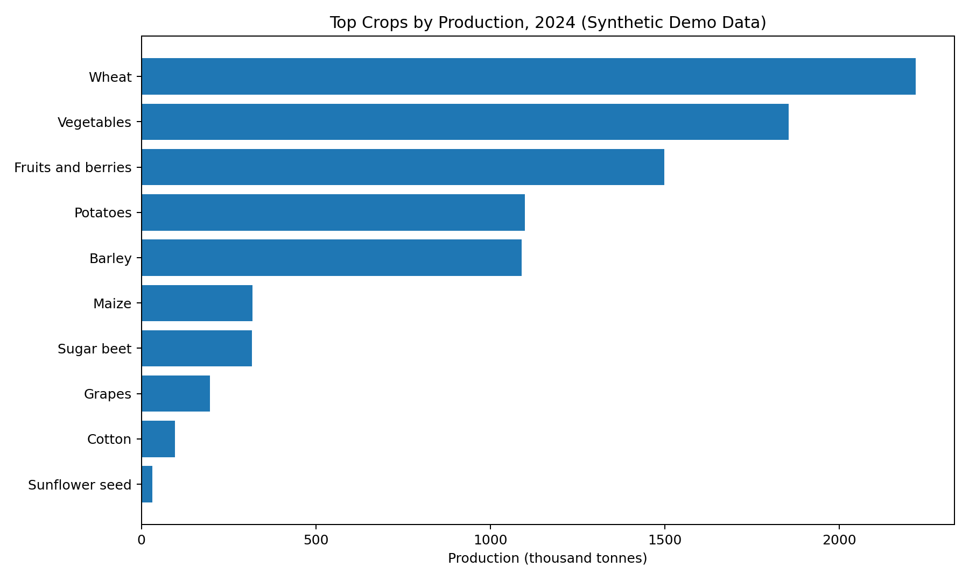

8.4 Area vs Production
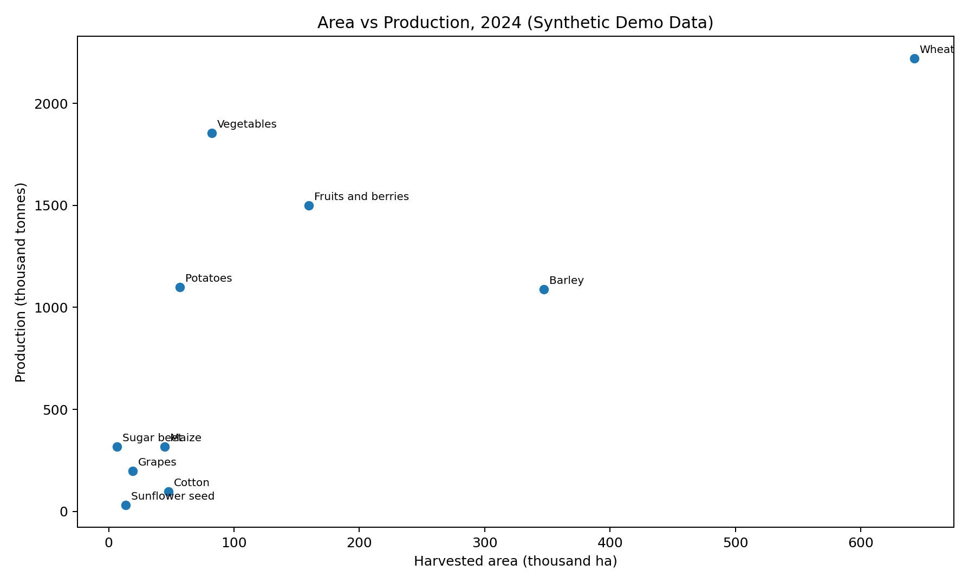

9. Business Insights
- Wheat is the largest crop by production volume in the latest demo year.
- High-yield crops such as vegetables and potatoes can create large output from smaller areas.
- Area expansion and yield improvement must be analyzed separately to understand the source of production growth.
- Maize shows the highest production volatility in the demo dataset, indicating higher planning risk.
- The dashboard should show production, area, yield, growth, and volatility together rather than relying on a single metric.

10. Recommendations
- Use yield improvement as a core productivity KPI, not only total production.
- Monitor volatile crops separately and connect them with weather, irrigation, and input availability data in future projects.
- Build a Power BI dashboard with year and crop slicers for recurring management reporting.
- Replace the synthetic dataset with official FAOSTAT or national statistics before using the analysis for real policy work.
- Extend the project into an intermediate-level portfolio project by adding regional comparison, forecasting, and climate indicators.

11. Limitations
- The current data is synthetic and must not be used as official evidence.
- No regional dimension is included in the demo dataset.
- Weather, price, subsidy, irrigation, and import-export variables are not yet included.
- The volatility score is a simple analytical proxy and should be expanded in advanced versions.

12. Future Improvements
- Add FAOSTAT official crop-level data.
- Add Azerbaijan regional data from national statistics.
- Develop Power BI dashboard pages for executive overview, crop performance, and volatility.
- Add time-series forecasting for strategic crops.
- Add climate variables and evaluate climate-yield relationships.
- Build a PostgreSQL or DuckDB analytical model for SQL practice.

13. Source Links
- FAOSTAT Crops and Livestock Products: https://www.fao.org/faostat/en/#data/QCL
- FAOSTAT bulk download metadata: https://bulks-faostat.fao.org/production/datasets_E.xml
- Our World in Data wheat production chart/API example: https://ourworldindata.org/grapher/wheat-production
- World Bank Agriculture & Rural Development: https://data.worldbank.org/topic/agriculture-and-rural-development
- Azerbaijan State Statistical Committee Agriculture: https://www.stat.gov.az/source/agriculture/

14. Interview Explanation
I built an end-to-end agricultural analytics portfolio project that analyzes crop production, harvested area, and yield indicators. I created a clean analytical dataset, engineered YoY growth and volatility metrics, built visual outputs, prepared an Excel dashboard workbook, and documented business insights and recommendations. The project is structured so that the demo dataset can be replaced with official FAOSTAT or national statistics.

